Social Media Best Practices for Trails and other Recreational Assets
It is important to have ongoing, consistent marketing through various social media outlets to help spread the word about your trail and its nearby attractions and activities. Here are some tips to engage your audience.
General:
- Make sure to post on a regular basis to keep followers engaged
- Visual posts (photos and videos) are the often the most “liked” and “shared” posts
- To maintain and strengthen your brand, use your logo in your profile pictures
- “Like” and tag other pages to help grow your page and presence
- Include your website in posts and profile to help drive traffic to your website
- Consider paid ads to target audiences whether geographically or interest-based
- If limited on time, schedule posts ahead of time to make sure your page is active
- Embed media pages to your website
- Include social media icons and links to help build your audience with your:
  - Website
  - Advertisements, brochures, etc
  - Bulletin Boards or Visitor Centers
  - Marketing campaigns (e-newsletters) and more

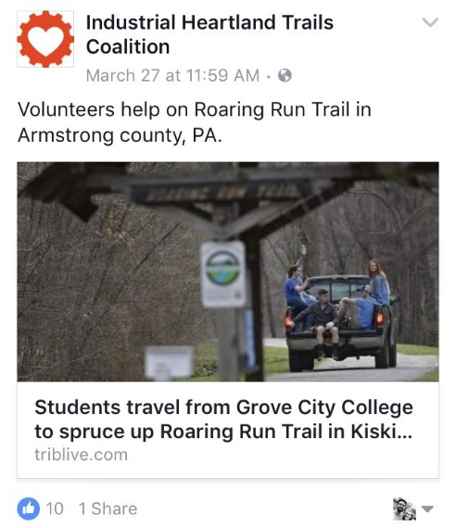
Content:
- Use images and videos that show the experience of your trail by highlighting different sections or unique spots that will inspire people to see for themselves
- Use images with people while showing diversity of users
- Share news links from local media as well as general trail and recreational resources
- Re-share or post information from local businesses or attractions to show there is more to do than just ride the trail or paddle the water
- Create event pages to supplement flyers and other marketing efforts
- Use hashtags that reflect your brand and trails
  - Name of trail, region, town/city
  - General tags such as #biking #railtrail #getoutdoors

