How to Create a Vision Statement for Your Outdoor Town
Planning for the Future: A Handbook on Community Visioning by the Center for Rural Pennsylvania describes community visioning as “both a process and a product.” The process gives residents the opportunity to come together and discuss what they value about their community, what they would like to change or preserve, and their aspirations for the future. The product of these discussions is the Vision, a statement of what residents value about their community and what they would like their community to look like in the future.
The process of developing a Vision statement is more important than the actual statement. The process helps residents to take a realistic look at their community; not to assign blame but to establish an honest appraisal of what their community is. This information is critical for developing a strategy for change. The product, the Vision statement, is important because it helps keep the community on track. Think of the statement as a compass that guides a community through the ups and downs of economic, social and political change.”
Does your town already have a Vision statement? If so, you need to think about how the Outdoor Town Vision will complement and enhance the existing Vision statement. As much as possible, your planning efforts should dovetail with other relevant planning efforts.
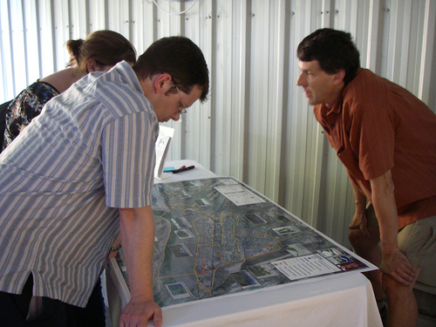
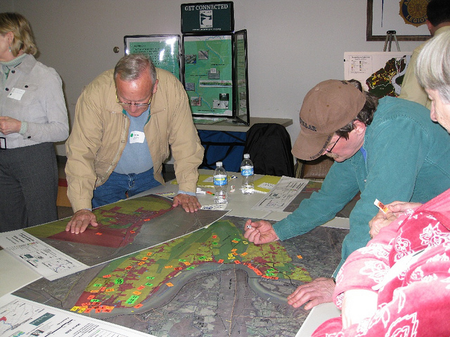
Community Members placing dots on map to show areas of concern and opportunity
Community Members discussing a potential project with the aid of an aerial map

Define Community Boundaries
The boundaries of your municipality may not be how you define your community. In Pennsylvania, as elsewhere, every township, borough, and city are linked together physically, economically, and culturally. These links should be the basis of a community’s boundary. To define their community, some groups have used the school district boundaries, some have used physical features such a river valley, or watershed region as the basis of their “community.” The purpose of defining a community’s boundaries is to give the vision a focus.
According to one count, Pennsylvania’s 2,580 municipalities can be boiled down to slightly more than 200 communities. Each of these places are unique and special. A Vision statement developed by residents in one community is not transferable to another community. Another reason for defining a community’s boundaries is to make the process more manageable. Focusing on a specific area can give residents a stronger sense of community and enable them to identify issues and affect change.
Gather Information on Community Assets, Values and Aspirations
Before you begin writing a Vision statement, it is necessary to gather as much information as possible, to get an accurate snapshot of the community and the resources it possesses.
Information on economic, demographic, and social conditions can be found at American FactFinder on the US Census website. Use this site to create a demographic profile of your community.
Complete the Asset Identification Form, Community Input Meeting, Community Survey and Community Assessment. Boil down the information that you have collected from these processes into the Community Input Summary Report. This will give you the information that you need to write the Vision statement.
Drafting the Vision Statement
A Vision statement should be written in the present tense, even though it is a projection of what the town will be five to 10 years in the future. It should be clear and concise, inspirational yet attainable. It should reflect the values and aspirations its residents.
Example Outdoor Town Vision Statement for Sylvan Glen
Sylvan Glen is a welcoming and walkable community where people can lead active and healthy lives. Natural resources are respected and enhanced. Residents and visitors can enjoy clean air and water, and outdoor recreational opportunities provided by parks, trails, forests and rivers. The community has maintained its heritage while adopting the newest technologies that support a vibrant local economy. There are ample opportunities to buy and enjoy locally made products and services. Volunteerism and community pride are strong and make Sylvan Glen a beautiful place to be.
To see other examples of community Vision statements, search the internet. Keep in mind that Vision statements, are not transferable from one community to another. They must come from an honest process of gathering values and aspirations, and building consensus on a shared Vision for the future.

